Name __________________________________________ Class _____________________

Angle Pairs Guided Practice – STUDENT WORKSHEET

- What kind of angle pair do angles 1 and 2 form? What is their relationship?

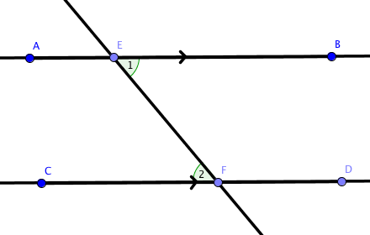
Alternate interior angles, they are congruent

- What kind of angle pair do angles 1 and 2 form? What is their relationship?

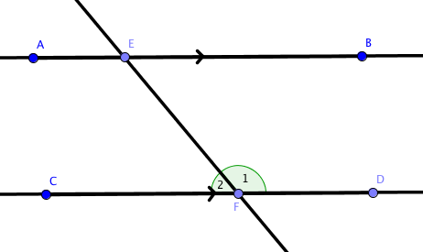
Linear pair of angles, they are supplementary

- What kind of angle pair do angles 1 and 2 form? What is their relationship?

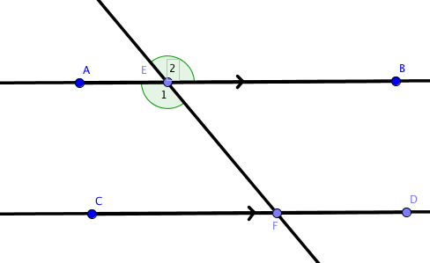
Vertical angles, they are congruent

- What kind of angle pair do angles 1 and 2 form? What is their relationship?

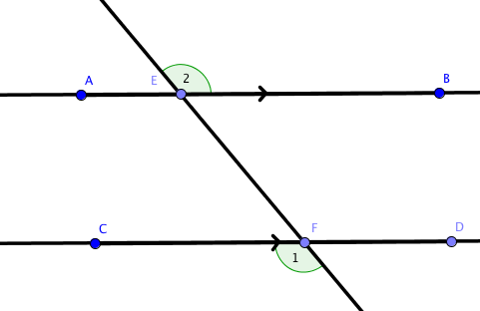
Alternate exterior angles, they are congruent

- What kind of angle pair do angles 1 and 2 form? What is their relationship?

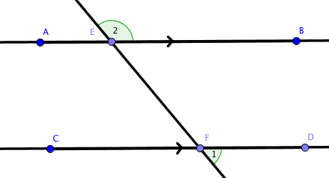
Same-side exterior angles or consecutive exterior angles, they are supplementary

- What kind of angle pair do angles 1 and 2 form? What is their relationship?

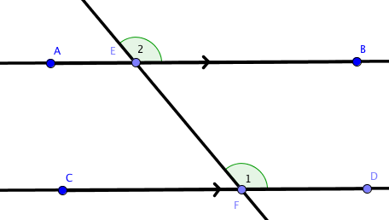
Corresponding angles, they are congruent

- What kind of angle pair do angles 1 and 2 form? What is their relationship?

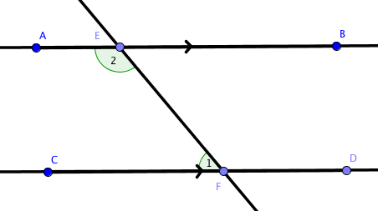
Same-side interior angles or consecutive interior angles, they are supplementary

