**Angle-Pair Relationships Worksheet**

1. **Alternate Interior Angles**

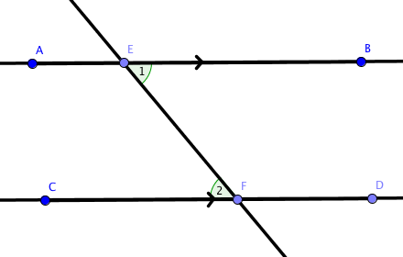

1. **Alternate Exterior Angles**

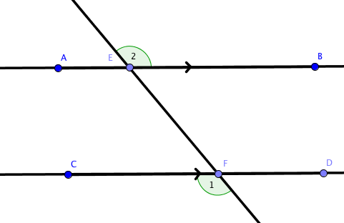

1. **Linear Pair**

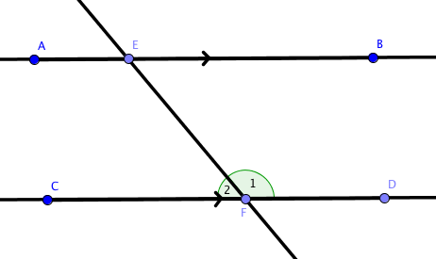

1. **Corresponding Angles**

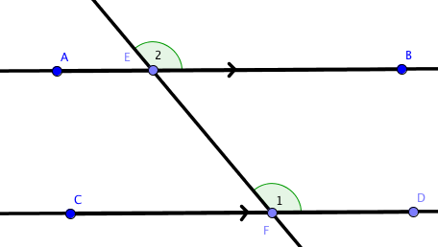

1. **Same Side Interior**

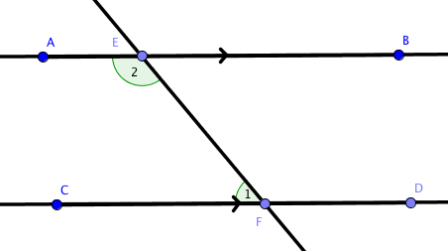

1. **Vertical Angles**

