Comparing Rates of Change Exit Ticket
6. The three different linear functions below are represented in three different ways, as shown.
Which function has the greatest rate of change? Does any pair of functions have the same rate of change? Justify your answer.
x | y
-2 | 10
0 | 12
2 | 14
- y = 3x+1 II.

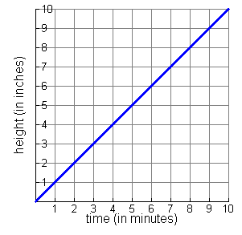
III.

