Name: ___________________________ Date: ___________________ Period: ______

Geometric Properties Quiz 2

Part 1: Angle Pair Relationships – Identify each pair of angles as corresponding, vertical, alternate interior, alternate exterior, same-side interior, or linear pair.

- _________________________________

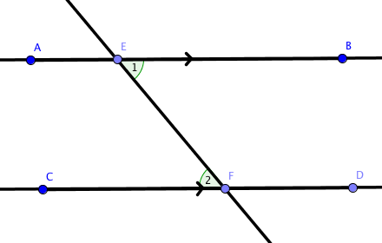

- _________________________________

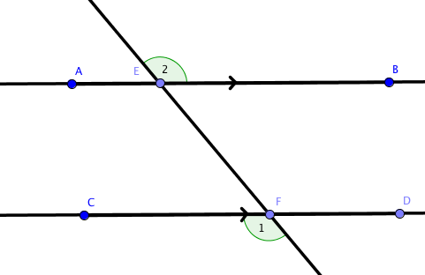

- _________________________________

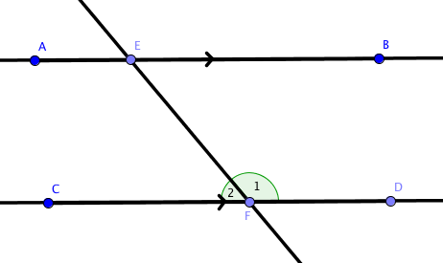

- _________________________________

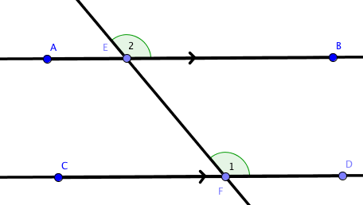

- _________________________________

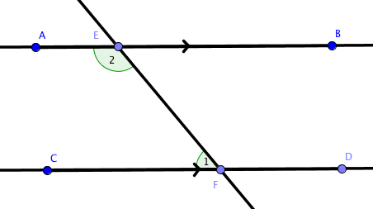

- _________________________________

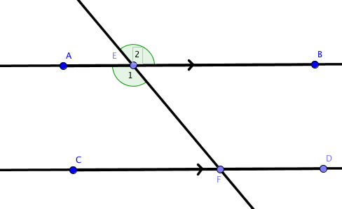

Part 2: Interior Angles of Triangles – For each triangle, find the value of ‘x’.

30°

4x+20
x+5

X = _____

25

3x + 5
x - 10

X = _____
- The measures of the angles of a triangle are given as 2x°, 3x° and 4x°. What are the measures of each angle?

X = _______ m<1 = _____

m<2 = _____ m<3 = _____

- One of the congruent angles of an isosceles triangle measures 71°. Find the measure of each of the other angles.

m<1 = _____ m<2 = _____
Part 3: Exterior Angles of Triangles – For each triangle, find the value of ‘x’.

30°
8+6x
4x +2

X = _____

x
50°
120°

X = _____

3x + 2
55

X = _____

13x - 3

15x + 5

6x + 6

X = _____
80°

Part 4: Similar Figures – Put the correct answer in each blank.

- In the diagram below, ABC ~ TUV.
A
T

15
12
25
20

V
U
30
24
B
C

  - Since the triangles are similar, identify all pairs of corresponding angles and sides.

    - <A corresponds to _________

    - <B corresponds to _________

    - <C corresponds to _________

    - AB corresponds to _________

    - BC corresponds to _________

    - AC corresponds to _________

  - Since the triangles are similar, identify the corresponding side lengths by writing a statement of proportionality.
$$\frac{AB}{}= \frac{}{UV}= \frac{AC}{}$$

Extra Credit:

- Substitute the lengths of the sides in the triangles above to write the ratios of the corresponding side lengths in a statement of proportionality.

------- = ------- = -------

- Reduce the ratio of your answer for number 1.

------- = ------- = -------

