Name: _____________________________________ Date:_______________

Monroe Doctrine Cartoons

Cartoon #1
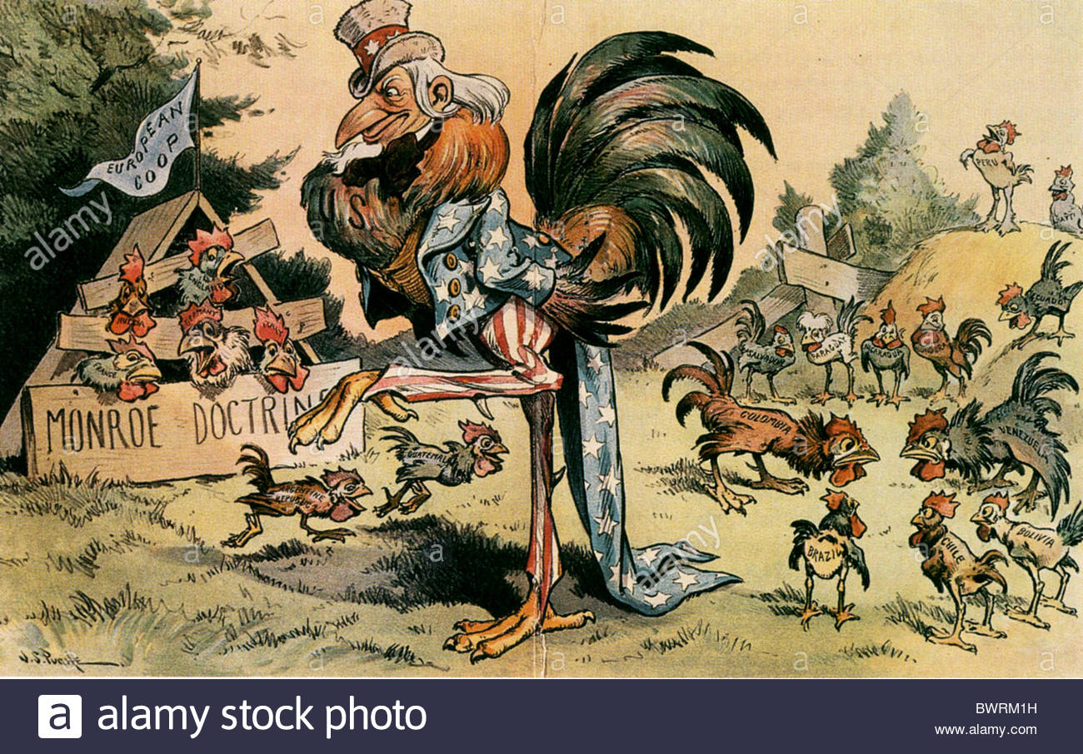

Questions:
- What is happening in the cartoon?

- Who does the figure in the foreground represent?

- Who are the figures in the background? See if you can read the names of the nations.

- What is the message of this cartoon?
Cartoon #2
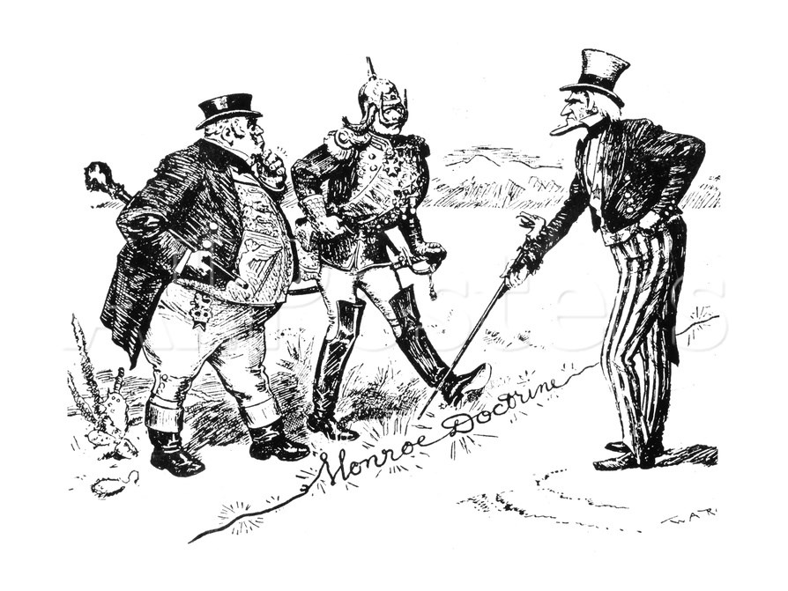

Questions:
- Describe what is happening in this cartoon.

- Who is the figure on the right?

- Who are the two figures on the left?

- What is the figure on the right pointing to?

- What is the message of this cartoon?

