One-Pager Assessment (TEST Grade)

Name: _____________________ Period: ______
Due Date: ______________

- Purpose: A one-pager is a single-page response to the topic and is a valuable way to own what you learn. We learn best when we can create our own pattern. A one-pager is a way of making your own pattern in order to demonstrate your unique understanding of a topic. It is a way to be creative and experimental while responding briefly and imaginatively. It is a way to be brief and compressed in a world drowning in paper.

- Select a topic from chapters 8 through 10 in the America textbook. This is your chance to delve further into a topic and demonstrate what you’ve learned about Washington’s Farewell Address, John Adams Thomas Jefferson, Andrew Jackson, the Louisiana Purchase, the War of 1812, etc. Use your chosen topic as a springboard to explore your own ideas. You can use your device or the textbook as resources, but the majority of this assignment will be completed at home.

- Use a visual image to create a central focus for your page. Cluster around this image(s) impressions, feelings, thoughts, key words, and quotes regarding what you have read or researched. You are expected to use color and cover the entire page with high-quality illustrations and information. Although paper will be provided in class, you are welcome to generate the final product on your computer and print on your own paper at home.

- Your one-pager must have at least 5 graphics and 1 quote. The rest of the information can be written in sentence or bullet point format.
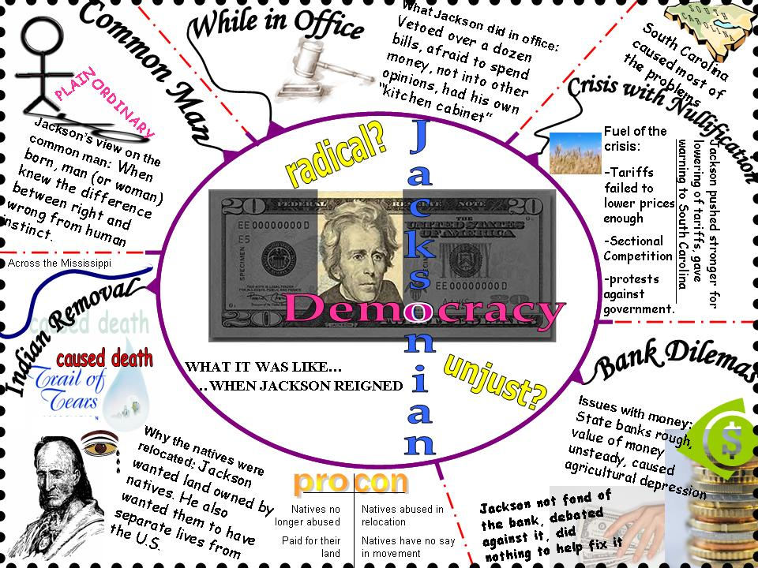
Possible Topics:
- George Washington
- The Whiskey Rebellion
- Origins of Political Parties
- Washington’s Farewell
- John Adams
- The Alien and Sedition Acts
- Thomas Jefferson
- The Louisiana Purchase
- The War of 1812
- James Madison
- Monroe Doctrine
- Andrew Jackson
- Student Choice: (Must be approved by the teacher by: Friday, 12/15/2017)
Category | 20 points each | 18 points each | 15 points each | 10 points each
Graphics - Relevance | All graphics (at least 5) are related to the topic and make it easier to understand. | All graphics (4) are related to the topic and most make it easier to understand. | All graphics (2-3) relate to the topic. | Graphics (1 or less) do not relate to the topic.
Graphics - Originality | Several of the graphics reflect an exceptional degree of student creativity in their creation and/or display. | One or two of the graphics used on the poster reflect student creativity in their creation and/or display. | The graphics are made by the student, but are based on the designs or ideas of others. | No graphics made by the student are included
Quality of Information | Information clearly relates to the main topic. It includes several supporting details and/or examples. | Information clearly relates to the main topic. It provides 1-2 supporting details and/or examples. | Information clearly relates to the main topic. No details and/or examples are given. | Information has little or nothing to do with the main topic.
Focus on Topic | There is one clear, well-focused topic. Main idea stands out and is supported by detailed information | Main idea is clear but the supporting information is general. | Main idea is somewhat clear but there is a need for more supporting information. | The main idea is not clear. There is a seemingly random collection of information.
Readability | The overall appearance of the one-pager is neat in appearance and easy to read. | The overall appearance of the one-pager is somewhat neat in appearance and easy to read. | The one-pager is relatively readable, but not very neat. | The one-pager is difficult to read.

