Parallel Lines Cut By a Transversal Investigation

Teacher Notes:

Materials:

Student page

Patty Paper

Protractor

Ruler

Pencil

Procedures:

1. Facilitate Student activity following the student page
2. When complete facilitate a class discussion of the findings

Parallel Lines Cut By a Transversal Investigation (Student Page)

Vocabulary

Parallel Lines – lines in the same plane that never intersect

Transversal – a line intersecting two or more lines

Congruent angles – angles with the same measure

Supplementary – a pair of angles whose sum is 180°

Conjecture – a conclusion based on something observed

Investigation

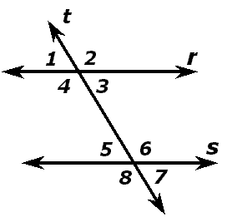In the figure below lines *r* and *s* are parallel and cut by transversal *t*.

Step 1: Copy the figure using a piece of patty paper

Step 2: Use your patty paper tracing and the original figure to determine the relationships between the following angle types. Use the terms congruent, supplementary, or cannot determine to identify the relationships. Record your findings in the provided tables.

Corresponding Angles:

|  |  |
| --- | --- |
| Angles | Relationship |
| and |  |
| and |  |
| and |  |
| and |  |

Write a conjecture about the relationship between corresponding angles formed when a pair of parallel lines is cut by a transversal.

______________________________________________________________________________________________________________________________________

_____________________________________________________________________________________

Alternate Interior Angles

|  |  |
| --- | --- |
| Angles | Relationship |
| and |  |
| and |  |

Write a conjecture about the relationship between alternate interior angles formed when a pair of parallel lines is cut by a transversal.

______________________________________________________________________________________________________________________________________

___________________________________________________________________

Same Side Interior Angles

|  |  |
| --- | --- |
| and |  |
| and |  |

Write a conjecture about the relationship between same side interior angles formed when a pair of parallel lines are cut by a transversal.

______________________________________________________________________________________________________________________________________

___________________________________________________________________

Alternate Exterior Angles

|  |  |
| --- | --- |
| and |  |
| and |  |

Write a conjecture about the relationship between alternate exterior angles formed when a pair of parallel lines is cut by a transversal.

______________________________________________________________________________________________________________________________________

___________________________________________________________________