The Picture Tells the (Linear) Story
Complete the table for each equation below. Then graph the equation on the axes provided. Finally, answer the questions that follow.
1. y = x  x y  −8  −4  0  4  8  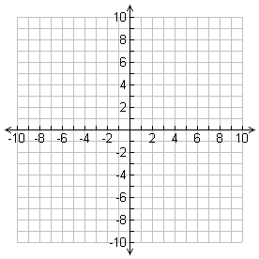 | 2. y = −x  x y  −8  −4  0  4  8
- How are the lines alike?

- How are they different?

3. y =2 x  x y  −4  −2  0  2  4 | 4. y = 3x  x y  −3  −2  0  2  3 | 5. y = 5x  x y  −2  −1  0  1  2
6. y = $\frac{1}{2}x$  x y  −8  −4  0  4  8 | 7. y = $\frac{1}{3}x$  x y  −9  −3  0  3  9 | 8. y = $\frac{1}{4}x$  x y  −8  −4  0  4  8

Refer to your graphs to answer the following questions:
- Describe the differences in the graphs.

- Which appears the steepest?

- Which appears flattest?

- What makes the difference?

- How is the equation of the line related to the graph of the line?

- When looking at the equation of the line, how can you determine if the graph will slant up from left to right without graphing the line?

- When looking at the equation of the line, how can you determine if the graph will slant down from left to right without graphing the line?

- Which of the following lines is the steepest?
y = ½ x y = 4x y = x y = 2x

Why?

