Review for Math 8 Unit 11 Test – Linear Functions & Equations of Lines
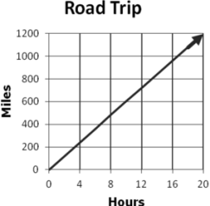

- The graph shows the time and distance of a car during a
road trip. What does the slope represent?

- What is the equation of a line that has a slope of -5 and goes through the origin?
A) y = -5x
B) y = -2
C) y = x - 5
D) y = -5x - 5

- What is the equation of a line that crosses the y -axis at (0, 3) and has a slope of -4?
A) $y=\frac{-4}{3}x$
B) $y=-\frac{3}{4}x$
C) $y=-4x-3$
D) $y=-4x+3$

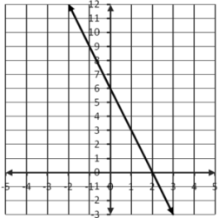

- A line is graphed in the coordinate grid. Which equation
represents this line?

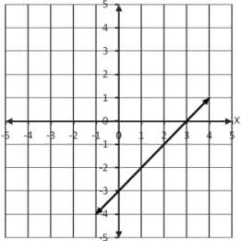
- A line is graphed in the coordinate grid. Which equation
represents this line?

- Consider the graph of the line shown. If the equation of the
line is written in the form y = mx + b what is the value of m?
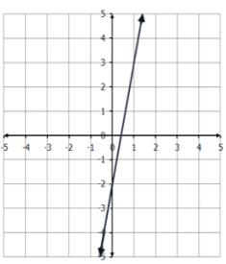
A) -5
B) -1
C) ½
D) 5

- Which graph represents a line with slope equal to -1?
A) Graph A
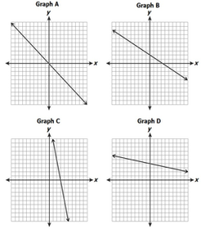
B) Graph B
C) Graph C
D) Graph D

- What is the slope and the y -intercept of a line whose equation is y = 2x + 5?
A) slope = 2; y -intercept = 5
B) slope = 5; y -intercept = 2
C) slope = -2; y -intercept = -5
D) slope = -5; y -intercept = 5

- What is the slope in the equation x = 11?
A) 11
B) 1
C) 0
D) no slope

- Which choice represents an equation of a line with slope of $\frac{1}{2}$and a y-intercept of 4?
A) 2y - x = 8
B) 2y + 4x = 2
C) 4y - 4x = 8
D) 2y - 2x = 4
- What is the slope of a line given the points (0, -2) and (6, 2)?

- $\frac{2}{3}$

B) $-\frac{3}{2}$
C) $\frac{3}{2}$

D) $-\frac{2}{3}$

- Which choice would most likely represent the graph of y = -5x + 5?

A)

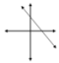
B)

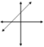
C)

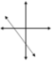
D)

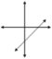

- Which expression represents a negative slope?

- $\frac{-2-6}{1-5}$

- $\frac{10-4}{-8-1}$

- $\frac{-6-6}{-5-3}$

D) $\frac{13-9}{12-6}$

- What is the equation of a line with a slope of 4 and passing through the point (5, 6)?
A) y = 4x − 26
B) y = −4x − 14
C) y = 4x − 14
D) y = 4x + 26

- What is the y -intercept of 2y + 5x = −20 ?
A) -10
B) -20
C) -4
D) 5

- What are the x and y -intercepts for y = 4x + 2?
A) x-intercept ( 0, -2); y-intercept ( -2, 0)
B) x-intercept (-2, 0); y-intercept (0, 2)
C) x-intercept (2, 0); y-intercept (0, -2)
D) x-intercept ( 0, 2); y-intercept (-2, 0)
- Analyze this equation x − 5y = 15. What is the y -intercept of this equation?
A) -3
B) -5
C) 1
D) 10

- Which line has an undefined slope?
A)

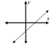
B)

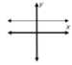

C)
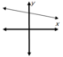
D)

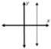

- The table shows a set of points on a line. What is the slope of the line?
A) −3
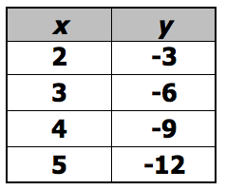
B) −13
C) 13
D) 3

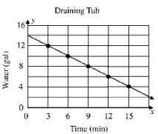
- The line represents the time it takes water to drain
from a bathtub. What is the slope of this line?
A) – 1
B) $-\frac{2}{3}$
C) $\frac{2}{3}$
D) 1

- Two linear equations are given. What do the two have in common?
A) the x -intercept
y – 8 = 4x
5y = 20x − 2

B) the y -intercept
C) the slope
D) The equations represent the same line.

- What is the slope of the line graphed in the
coordinate plane?
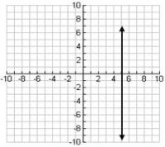
A) -5
B) 0
C) 5
D) Undefined

- Which equation would pass through the origin and have a slope of $\frac{3}{7}$ ?
A) $\frac{3}{7}y=x$
B) $y=\frac{3}{7}x$
C) $x=\frac{3}{7}y+1$
D) $y=\frac{3}{7}x-\frac{3}{7}$

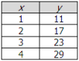
- The table gives ordered pairs of a function. Which
rule describes the ordered pairs in the table?
A) y = x + 10
B) y = 3x + 4
C) y = 6x + 5
D) y = 8x + 3

- When plotted on the coordinate plane, which line will have the steepest slope?
A) y = -5x
B) y = 8x
C) y = -11x
D) y = 9x

