Name: ________________________________ Unit 13 – Systems of Equations Review

- Solve each systems of equations by graphing.

- y = 2x + 4
y = - $\frac{1}{2}$x + 4

SOLUTION: _______________
- 2x + 4y = -4
y – 1 = $\frac{1}{2}$x

SOLUTION: _______________

- Solve each system of equations using SUBSTITUTION. Show all your work.

- y = 2x – 4 Solution: ___________
– x + 3y = 3

- x = y + 13 Solution: ___________
y – x = – 13

- x = y – 7 Solution: ___________
x + 5y = –1

- x + y = 4 Solution: ___________
y = 7x + 4

- Solve each system of equations using ELIMINATION. Show all your work.

- –3x +5y=12 Solution: ___________
2x –5y = –2

- x + y = 19 Solution: ___________
2x + y = –7

- –4x –2y = –12 Solution: ___________
4x + 8y = –24

- 7x + 2y = 24 Solution: ___________
8x + 2y = 30

- Solve each word problem using systems of equations. Show all your work.

- The sum of two numbers is 27. Their difference is 7. Find the two numbers.
Number: _______

Number: _______

- 215 people attended a basketball game. The admission was $10 for adults and $5 for students. The receipts from the game totaled $2075. How many adults and how many students went to the game?
Adults: _________

Students: _______

- The length of a rectangle is three centimeters more than three times the width. If the perimeter of the rectangle is 46 centimeters, find the dimensions of the rectangle.
Width: __________

Length: _________

- The sum of two numbers is 82. Their difference is 24. Find the two numbers.
Number: _______

Number: _______

- Multiple Choice: Read each question carefully and circle the letter of the correct answer.
x – 3y = 9
2x + 3y = 15
- To solve the following system by elimination, what is the most logical first step?

  - Solve the 1st equation for x
  - Solve the 2nd equation for y
  - Add the equations
  - Subtract the equations

- To solve the following system by substitution of x, what is the most logical first step?
2x + y = 6
3x – 2y = 2

  - Solve the 1st equation for x
  - Solve the 2nd equation for y
  - Add the equations
  - Subtract the equations

- If the following system of equations is solved by elimination, what is the value of x?
3x + 5y = 16
8x – 5y = 28

  - 4
  - 5
  - – 6
  - 7

- Matching: Match each graph with the appropriate solution.
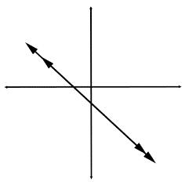
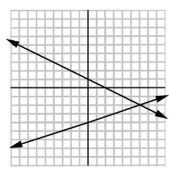
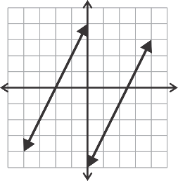
- One Solution _______

- No Solution: _______

- Infinite Solutions: _______

