Unit 8 Volume REVIEW Name: ___________________________________
This review is due on the day of your test. SHOW ALL WORK for credit.
WRITE ALL FORMULAS and give answers with proper units. Round to the nearest tenth unless directed otherwise.

- Find the area of a circle with radius 19.4 m.

- Find the AREA of the figure below.
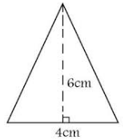

- Determine the volume. Round to the nearest hundredth.
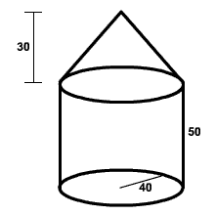
- Find the volume (to the nearest tenth).
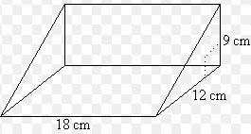

- A large concrete block is made to be the cornerstone for a building. The block is 16 ft deep, 10 ft wide, and 17 ft long. What volume of concrete is needed to make this block?

- A cylindrical container of corn has a diameter of 11 cm and a height of 8 cm. Find the volume of the container of corn.

- Find the volume of the figure.
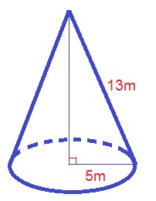
- A county has constructed a cone-shaped building to store sand. The cone has a height of 142 m and diameter of 390 m. Find the volume of this building to the nearest hundredth.

- Determine the volume of a sphere with a radius of 8.6 cm, both in terms of π and to the nearest tenth.

Multiple Choice – SHOW ALL WORK

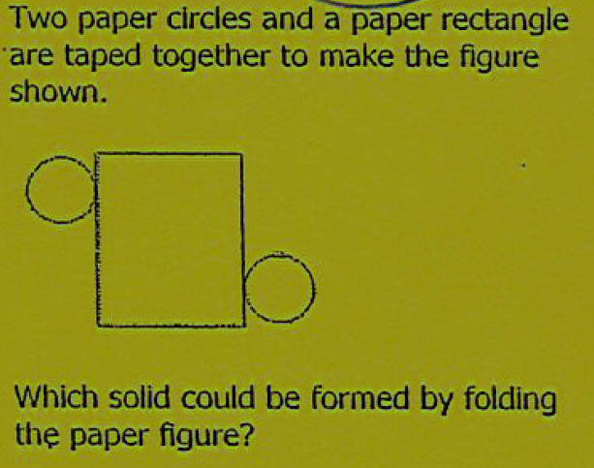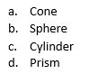

- A cylinder has the dimensions marked:
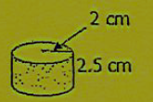
Which statement is most accurate?
- The volume is approximately 40 cubic centimeters.
- The volume is exactly 40 cubic centimeters.
- The volume is approximately 30 cubic centimeters.
- The volume is exactly 30 cubic centimeters.

- John collects marbles. He stores his marbles in an old tin can that his grandmother gave him. The tin can has a shape of a cylinder with a diameter of 8 inches and a height of 12 inches.
If 1 cubic inch holds 2 marbles, approximately how many marbles can the can hold?
- 201 marbles
- 804 marbles
- 1,206 marbles

Formulas: List the Volume formulas below:
Volume Formulas
Rectangular Prism | Triangular Prism | Cylinder | Cone | Sphere

