**Unit 9 Review**

**1. State the inputs and outputs for the following ordered pairs.**

**{(-6, 5), (2, 5), (1, 20), (-6, -10)}**

Inputs:_______________ Outputs:_______________

Is this a function and why or why not?

**2. Graph the following equation:**



Is this a function? ­­ YES or NO

Explain your reasoning:

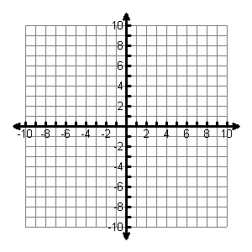

3. Explain why *x*2 + *y*2 = 49 is not a function. *(Hint: What are some ordered pairs that would satisfy this equation?)*

4. Sketch a graph that represents your lunch period. Set up your graph, so that the x-axis is time and y-axis is distance from classroom. Provide a description of your sketch.

5. Describe the graph of the function between *x* = 2 and *x* =4? Use words such as increasing, decreasing, linear, or non-linear.

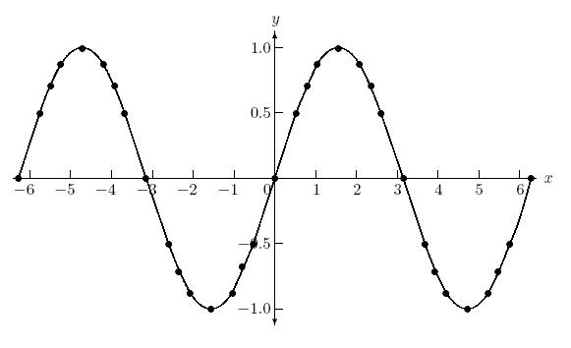

6. The three different linear functions below are represented in three different ways, as shown.

Which function has the greatest rate of change? Does any pair of functions have the same rate of change? **Justify your answer.**

|  |  |
| --- | --- |
| **x** | **y** |
| **-2** | **10** |
| **0** | **12** |
| **2** | **14** |

1. **y = 3x+1 II.**

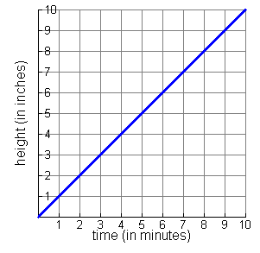**III.**

7. Of the three linear functions represented below, which has the greatest rate of change?

A. Jalyn loves video games. She just bought a new one. Currently she is having to restart two times a minute.

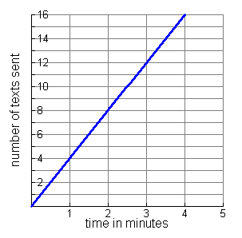B. {(2, 3), (3, 4), (4, 5), (5, 6)}

C.

8. Create a verbal description for the equation y = 3x + 1