Formula | Shape
Rectangular Prism  $$V=Bh$$  $$V=lwh$$ | 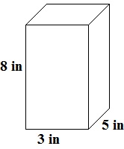
Triangular Prism  $$V=Bh$$  $$V=\frac{1}{2}\left(bh\right)h$$ | 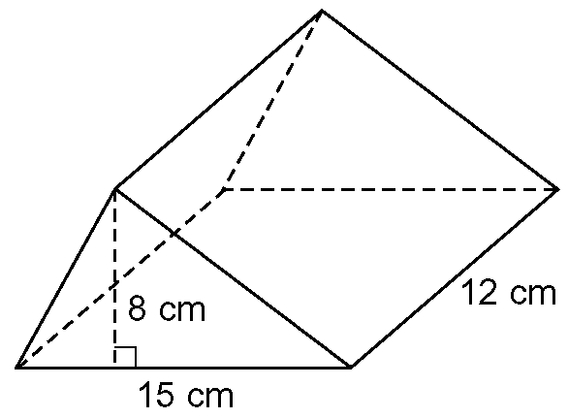
Cylinder  $$V=Bh$$  $$V=\left(πr^{2}\right)h$$ | 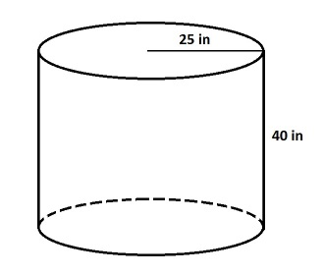
Cone  $$V=\frac{1}{3}Bh$$  $$V=\frac{1}{3}\left(πr^{2}\right)h$$ | 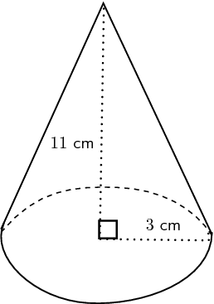
Sphere  $$V=\frac{4}{3}πr^{3}$$ | 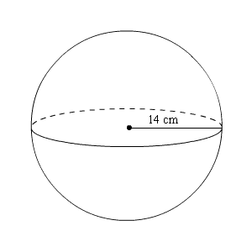
Volume Formulas

Formula | Shape
Rectangular Prism

$$V=Bh$$
$$V=lwh$$
Triangular Prism

$$V=Bh$$
$$V=\frac{1}{2}\left(bh\right)h$$
Cylinder

$$V=Bh$$
$$V=\left(πr^{2}\right)h$$
Cone

$$V=\frac{1}{3}Bh$$
$$V=\frac{1}{3}\left(πr^{2}\right)h$$
Sphere

$$V=\frac{4}{3}πr^{3}$$
Volume Formulas
Formula | Shape
Rectangular Prism

$$V=Bh$$
$$V=lwh$$
Triangular Prism

$$V=Bh$$
$$V=\frac{1}{2}\left(bh\right)h$$
Cylinder

$$V=Bh$$
$$V=\left(πr^{2}\right)h$$
Cone

$$V=\frac{1}{3}Bh$$
$$V=\frac{1}{3}\left(πr^{2}\right)h$$
Sphere

$$V=\frac{4}{3}πr^{3}$$

