Volume of a Sphere

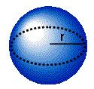

Formula for volume of a sphere:

$$V=\frac{4}{3}πr^{3}$$

Where *r* is the radius of the sphere.

Find the volume of each sphere. Round all answers to the nearest hundredth.

|  |  |
| --- | --- |
| 5 cm | 14 in |
| 2.5 cm | What would be the volume of a sphere with a diameter of 13 cm? |