Minutes | Water balloons filled
1 | 2
2 | 4
3 | 6
4 | 8
5 | 10
6 | 12

Water Balloon Warm-Up

- Use the table to the right to answer the questions below.
  - Based on the table, is this a linear function?

  - How do you know?

  - If so, what is the rate of change?

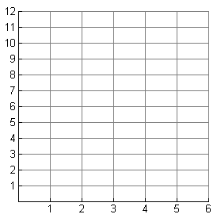
- Graph the data from the table. Remember to label your axes.
  - Does your graph confirm your answer to 1a?

  - Find the slope of your graph.

  - What answer in #1 does your slope match?

  - Does this make sense? Why or why not?

- Write a verbal description of this situation. How does this connect to the table and the graph?

- Write an input/output equation to represent this situation. How does it relate to the other representations?

