Name: Date:
U.S. History Launching the New Nation

Directions: Read the section below and answer the questions that follow in complete sentences.

No protesting the government? No immigrants allowed in? No freedom of the press? Lawmakers jailed? Is this the story of the Soviet Union during the Cold War? No. It describes the United States in 1798 after the passage of the Alien and Sedition Acts.
President Adams took strong steps in response to the French foreign threat which included severe repression of protest. A series of laws known collectively as the Alien and Sedition Acts were passed by Congress in 1798 and signed into law by President Adams. These laws included new powers to deport foreigners as well as making it harder for new immigrants to vote. Previously a new immigrant would have to reside in the United States for five years before becoming eligible to vote, but a new law raised this to fourteen years.
The most controversial of the new laws permitting strong government control over individual actions was the Sedition Act. In essence, this Act prohibited public opposition to the government. Fines and imprisonment could be used against those who "write, print, utter, or publish . . . any false, scandalous and malicious writing" against the government.
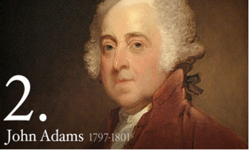
Under the terms of this law over twenty newspaper editors were arrested and some were imprisoned. The Sedition Act clearly violated individual protections under the first amendment of the Constitution; however, the practice of "judicial review," whereby the Supreme Court considers the constitutionality of laws was not yet well developed.

Questions:

- Why did President Adams sign the Alien and Sedition Acts into law?
____________________________________________________________________________________________________________________________________________________________
- What powers did the new Alien and Sedition Acts give to the federal government?
__________________________________________________________________________________________________________________________________________________________________________________________________________________________________________
- In your opinion, did the Alien and Sedition Act violate any of your rights as an American citizen? Give examples to support your opinion.



